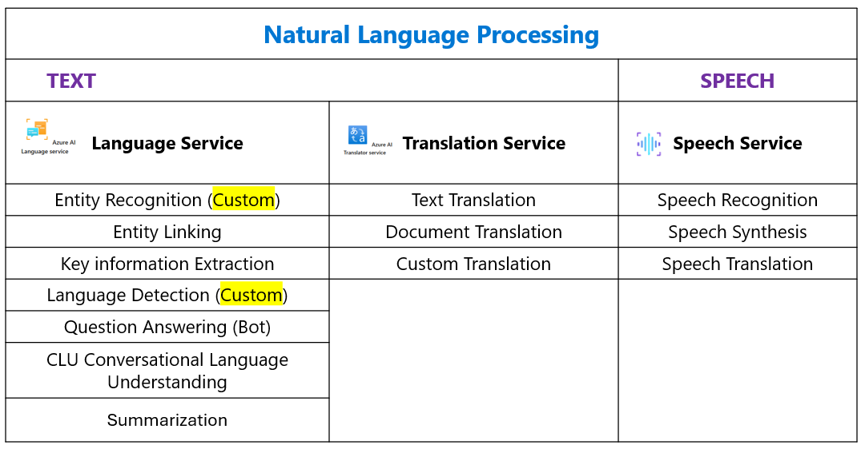
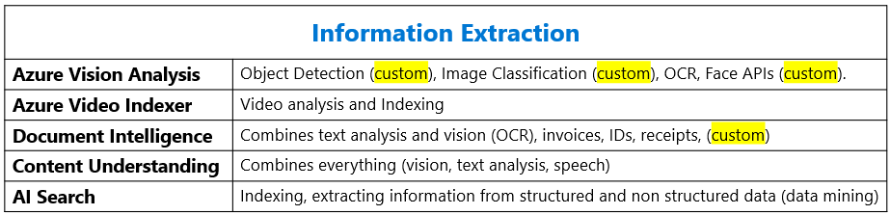

- Azure AI Services: a comprehensive suite of tools and APIs designed to help developers and organizations build intelligent, market-ready applications. These services provide prebuilt and customizable models, enabling rapid integration of AI capabilities into applications without requiring extensive expertise in machine learning. it can be used with a single API and authentication key, and provide separate billing for each service if needed.
- Azure AI Language is a part of the Azure AI services offerings that can perform advanced natural language processing over unstructured text.
- Sentiment analysis identifies whether text is positive, negative or neutral.
- Key phrase extraction lists the main concepts from unstructured text.
- Questions Answering typically, question answering is used to build bot applications that respond to customer queries (Bot Service), it can generate questions from a knowledge based with sources like Webpage, an existing FAQ or manually entered data.
- Language detection identifies the language of the text and returns a language code such as "en" for English.
- Named entity recognition identifies people, places, events, and more. This feature can also be customized to extract custom categories.
- Entity linking identifies known entities together with a link to Wikipedia.
- Summarization summarizes text by identifying the most important information.
- Conversational language understanding (CLU) describes a set of features that can be used to build an end-to-end conversational application. It enable you to customize natural language understanding models to predict the overall intention of an incoming phrase and extract important information from it. It utilize three concepts that are the building blocks for interpreting user input: utterance, intent, and entity.
- Utterance: The actual text or speech provided by the user.
- Intent: the goal or purpose behind the utterance the action the user wants to perform
- Entity: Specific data points or parameters extracted from the utterance that give context to the intent
- Azure AI Translator is a translation service that allows users to translate text and documents using a simple REST API call. It supports Real-time translation between supported source and target languages, Batch translation for complex files while preserving document structure, in addition to Custom translation memory for tailored translations and it can be connected to Azure Blob Storage.
- Text translation used for quick and accurate text translation in real time across all supported languages.
- Document translation used to translate multiple documents across all supported languages while preserving original document structure.
- Custom translation used to enable enterprises, app developers, and language service providers to build customized neural machine translation (custom dictionary) or domain specific terminology.
- Speech Synthesis converts text into human-like synthesized speech. It supports prebuilt neural voices and allows for the creation of custom voices tailored to specific brands or applications.
- Speech Recognition convert speech to text and it can be used in transcribing phone calls or other applications requires speech to text format
- Speech Translation Service supports real-time translation of speech into other languages, enabling seamless communication across linguistic barriers. This service provides both speech-to-text and speech-to-speech translation capabilities, making it versatile for various applications.
- Knowledge mining solutions provide automated information extraction from large volumes of often unstructured data and provide indexing so this information can searchable, AI search is the tool used with knowledge mining.
- Document Intelligence: one of the information extraction tools, combines both OCR vision capability along with NLP to understand structured documents like invoice, IDs, receipts, business cards, or custom documents formats.
- Universal Language Model Speech to Text API is a versatile tool that allows developers to convert audio into text transcriptions with high accuracy and context understanding. its optimized for dictation and conversational scenarios.
- Azure AI Speech Service: comprehensive service that provides speech-to-text, text-to-speech, speech translation, and speaker recognition capabilities in addition to voice assistants.

- ____________________________: a comprehensive suite of tools and APIs designed to help developers and organizations build intelligent, market-ready applications. These services provide prebuilt and customizable models, enabling rapid integration of AI capabilities into applications without requiring extensive expertise in machine learning. it can be used with a single API and authentication key, and provide separate billing for each service if needed.
- ____________________________: is a part of the Azure AI services offerings that can perform advanced natural language processing over unstructured text.
- ____________________________: identifies whether text is positive, negative or neutral.
- ____________________________: lists the main concepts from unstructured text.
- ____________________________: typically, question answering is used to build bot applications that respond to customer queries (Bot Service), it can generate questions from a knowledge based with sources like Webpage, an existing FAQ or manually entered data.
- ____________________________: identifies the language of the text and returns a language code such as "en" for English.
- ____________________________: identifies people, places, events, and more. This feature can also be customized to extract custom categories.
- ____________________________: identifies known entities together with a link to Wikipedia.
- ____________________________: summarizes text by identifying the most important information.
- ____________________________: describes a set of features that can be used to build an end-to-end conversational application. It enables you to customize natural language understanding models to predict the overall intention of an incoming phrase and extract important information from it. It utilizes three concepts that are the building blocks for interpreting user input: utterance, intent, and entity.
- ____________________________: The actual text or speech provided by the user.
- ____________________________: the goal or purpose behind the utterance the action the user wants to perform
- ____________________________: Specific data points or parameters extracted from the utterance that give context to the intent
- ____________________________:is a translation service that allows users to translate text and documents using a simple REST API call. It supports Real-time translation between supported source and target languages, Batch translation for complex files while preserving document structure, in addition to Custom translation memory for tailored translations and it can be connected to Azure Blob Storage.
- ____________________________: used for quick and accurate text translation in real time across all supported languages.
- ____________________________: used to translate multiple documents across all supported languages while preserving original document structure.
- ____________________________: used to enable enterprises, app developers, and language service providers to build customized neural machine translation (custom dictionary) or domain specific terminology.
- ____________________________: converts text into human-like synthesized speech. It supports prebuilt neural voices and allows for the creation of custom voices tailored to specific brands or applications.
- ____________________________: convert speech to text and it can be used in transcribing phone calls or other applications requires speech to text format
- ____________________________: supports real-time translation of speech into other languages, enabling seamless communication across linguistic barriers. This service provides both speech-to-text and speech-to-speech translation capabilities, making it versatile for various applications.
- ____________________________: solutions provide automated information extraction from large volumes of often unstructured data and provide indexing so this information can searchable, AI search is the tool used with knowledge mining.
- ____________________________: one of the information extraction tools, combines both OCR vision capability along with NLP to understand structured documents like invoice, IDs, receipts, business cards, or custom documents formats.
- ____________________________: is a versatile tool that allows developers to convert audio into text transcriptions with high accuracy and context understanding. its optimized for dictation and conversational scenarios.
- ____________________________: comprehensive service that provides speech-to-text, text-to-speech, speech translation, and speaker recognition capabilities in addition to voice assistants.

